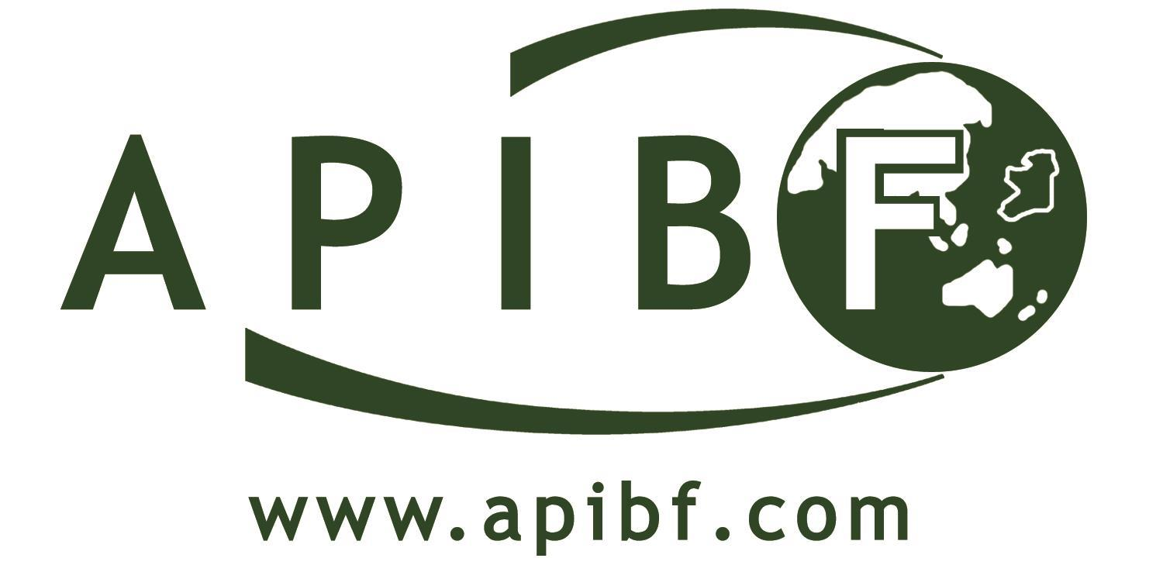 |  | 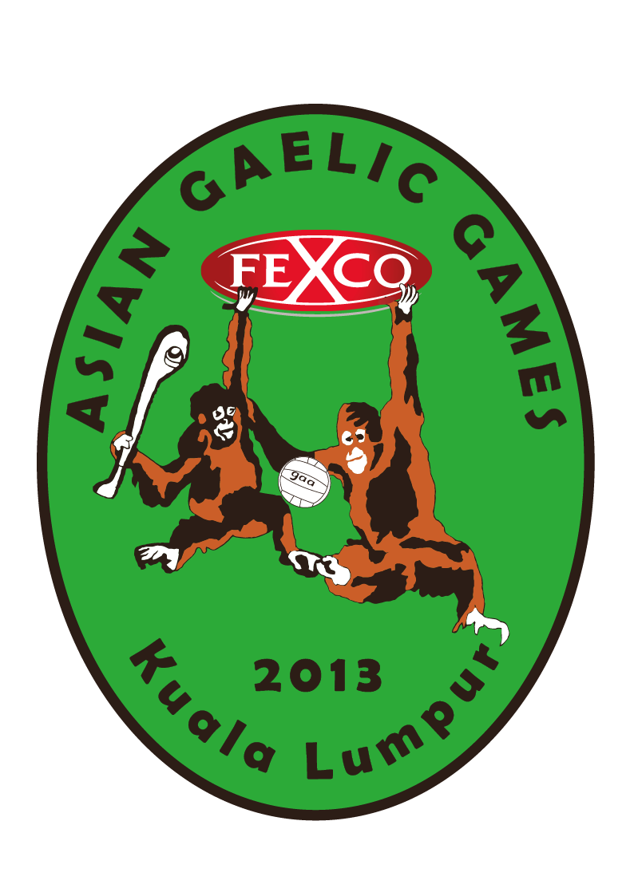

ASIA PACIFIC BUSINESS FORUM 2013
10th & 11th October 2013
In Conjunction with the
FEXCO ASIAN GAELIC GAMES 2013
12th & 13th October 2013

Kuala Lumpur, Malaysia

Main Sponsors:
 | 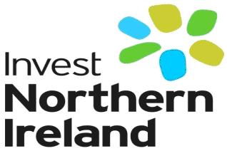 |  | 
Supported by:
 |  | 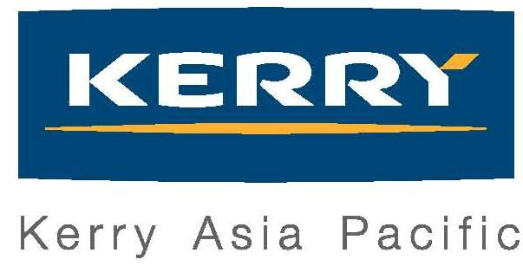 | 

Organised by:
 | 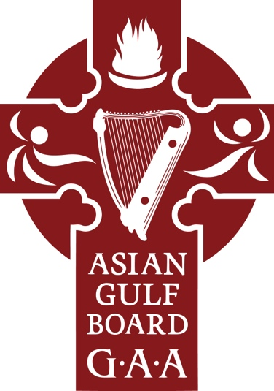
MIBN SECRETARIAT OFFICE:
Suite 5.18, Level 5, North Block, The AmpWalk, 218 Jalan Ampang, 50450 Kuala Lumpur
Tel: +603-2163 2309 Fax: +603-2775 2889 Email: secretary@mibn.com.my

APIBF 2013
10th & 11th OOCTOBER 2013
PARKROYAL HOTEL, KUALA LUMPUR, MALAYSIA

AGENDA
{This agenda is subjected to minor changes at the discretion of the Organisers}

Thursday, 10th October 2013
5.30 – 6.00 pm | Delegate Registration
6.00 pm – 7.30pm | Welcome Cocktail Reception
7.30 – 9.30 pm | APIBF Welcome Dinner*
 | Keynote Speaker:
 | - Mr. Dermot O’Shea ~ Executive Director, Fexco

*This event item is chargeable at RM 200.00 per person. Kindly register for this under the Registration segment “APIBF Welcome Dinner”

Friday, 11th October 2013
7.30 – 9.00 am | Power-Breakfast Friday
 | Introducer: Mr. Ron Anderson ~ Chairman, MIBN
 | - Mr. Tony O’Reilly Jr. – CEO Providence Resources
 | - Myanmar – Insights & Information
 | - H.E. Ambassador Damien Cole
 | - Gareth McGeown ~ Coca-Cola Myanmar
 | - Frank O’Carroll – Digicel Myanmar
9.30 – 10.30 am | Regional Irish Ambassadors Roundtable
 | Moderator: Mr. Clifford Coonan ~ Irish Times
10.30 – 11.00 am | Coffee Break
11.00 am – 12.00 pm | Ireland’s Best Of: Perspectives on Ireland & Asia
 | Moderator: Mr Paraic McGrath ~ Director, ESB International / Co-Founder, APIBF
 | - Financial Services: Mr Brian Conlon ~ CEO First Derivatives
 | - Education: Dr Jim Browne ~ President NUI Galway
 | - Energy: Mr Ollie Brogan ~ M.D ESBI
 | - GAA: Mr Martin Skelly – Vice President GAA.
12.00 – 12.30 pm | Interview: Mr. Mark Rohan ~ 2012 London Para-Olympic Double Gold Medallist
 | Conducted by: Michael O’Muircheartaigh – ACB Honorary President, Broadcaster.
12.30 – 2.00 pm | Luncheon
 | Keynote Address:
 | - Mr. Fergus O’Dowd ~ Irish Minister for State Dept. Communication, Energy & Natural Resources
 | - Mr Brian Mullins, Director of Sports, UCD
 | - Mr. Paul Dillon ~ Farmleigh Fellowship 2013
2.00 – 2.30 pm | Government Agencies of Ireland
 | Moderator: Mr. Paul Scales ~ Chairman Irish Thai Chamber
 | - Invest Northern Ireland – Mr. Michael Garvey
 | - Enterprise Ireland – Mr. Alan Dixon
 | - IDA – Mr. Brian Conroy
2.30 – 3.30 pm | Small & Medium Enterprises
 | Moderator: Mr. Micheal Collins
 | - ASEAN IPR SME Helpdesk
 | - Asia Trade Forum – Dublin
 | - SME Corp Malaysia
 | - SME Vietnam – Glandore Systems
 | - Michael Noble - Farmleigh Fellow 2012
3.30 – 4.00 pm | Presentation: Christina Noble Children’s Foundation
 | Ms Christina Noble, OBE ~ CEO
4.00 – 4.30 pm | Closing Remarks
 | H.E. Declan Kelly ~ Ambassador of Ireland to Malaysia
~ Forum Ends with refreshments in Foyer~
7.00 pm onwards | Asia Gaelic Games Reception – Hotel Istana

The ACB Asian Gaelic Games will be held on 12th & 13th October 2013

~ This space is intentionally left blank ~
APIBF 2013
10th & 11th OOCTOBER 2013
PARKROYAL HOTEL, KUALA LUMPUR, MALAYSIA

ACCOMMODATION BOOKING INFORMATION

Accommodation rooms have been blocked at preferred APIBF rates with Parkroyal Hotel Kuala Lumpur. Rates are as follows:

Room Category | Rate per night (inclusive of taxes) | Remarks
Superior | RM 350 nett (inclusive 1 breakfast)
Deluxe (King / Double) | RM 415 nett (inclusive 1 breakfast) | Limited to 60 rooms only
Orchid Club | Single: RM 465 nett | Inclusive of Club Floor Lounge Privileges
Orchid Club | Double: RM 545 nett | Inclusive of Club Floor Lounge Privileges

How to book:
To enjoy these rates for the duration of APIBF 2013, please log on to www.parkroyalhotels.com/apibf for bookings.

APIBF 2013 REGISTRATION

To register your seat for the APIBF 2013, please log on to
http://www.apibf.com/events/upcoming-events.html?task=register&event=14

~ We look forward to welcoming you at APIBF 2013 Kuala Lumpur, Malaysia!~

